Unity Team
Matteo Dell’Oro, Alfio Giuliano Faro, Gabriel Logronio

STORY DOCUMENT

Purpose | Document keeping track of the plot of the game
Creation date | 06-11-2017
Current owner | Alfio Giuliano Faro
Last modification | 23-11-2017

Revision History
Who | When | What
Dell’Oro | 06-11-2017 | Created the document
Logronio | 22-11-2017 | Modified the document
Logronio | 23-11-2017 | Added Backstory

Backstory

Season 4 Episode 6: Jenny, the doctor’s daughter, was left by the Doctor who thought she was dead. She took a shuttle and started exploring the universe, seeking adventures as her father did. She finally gets to the Earth where she stopped hoping to meet her father once again. Here she meets Jack and joins his team.

Season 4 Special Episodes: Jack Harkness is left alone in Torchwood. Following temporal anomaly signals, he manages to meet and recruit Jenny and Sam in his group. Together they help humans with alien issues, when they receive an anonymous message informing them that a Tardis has landed nearby, they reach its location thinking it’s the Doctor.

Season 8 Episode 1: Strax, while working on a case with Madame Vastra and Jenny, mysteriously disappears, without leaving any trace.

Season 9 Episodes 1-2: The Doctor left Missy in Dalek’s hands. She bargains her life for Gallifrey and makes an alliance with the Daleks. They help her to capture the Doctor and she manages to clone him: using these clones she gathers an army that she can control at her will.

Season 9 Episode 6: Sam Swift has become immortal due to Ashildr and the Doctor. He has then fallen into depression: he has outlived every single person he knew and now sees his immortality as a curse. He then meets Jack Harkness and decides to join him in order to meet the Doctor and finally find a way to die.

Season 9 Episode 12: After deleting every memory of Clara from the Doctor’s mind, Clara and Ashildr have to go back to Clara’s death moment, a fixed point in time. They decide to “take the long way” and visit the universe as much as they can before heading back to the final moment.

Plot

Clara and Ashildr decide to start their own journey using the Tardis, in the light of adventures that they had with the Doctor. Before heading back to Clara’s inevitable death, they travel all around the galaxy trying to save as many lives as they can. A temporal anomaly forces the Tardis to stop in Roswell, in 1947: an UFO is rumoured to have crashed but it was only found 6 days after the actual crash. What happened in that time gap? Our story starts right here.

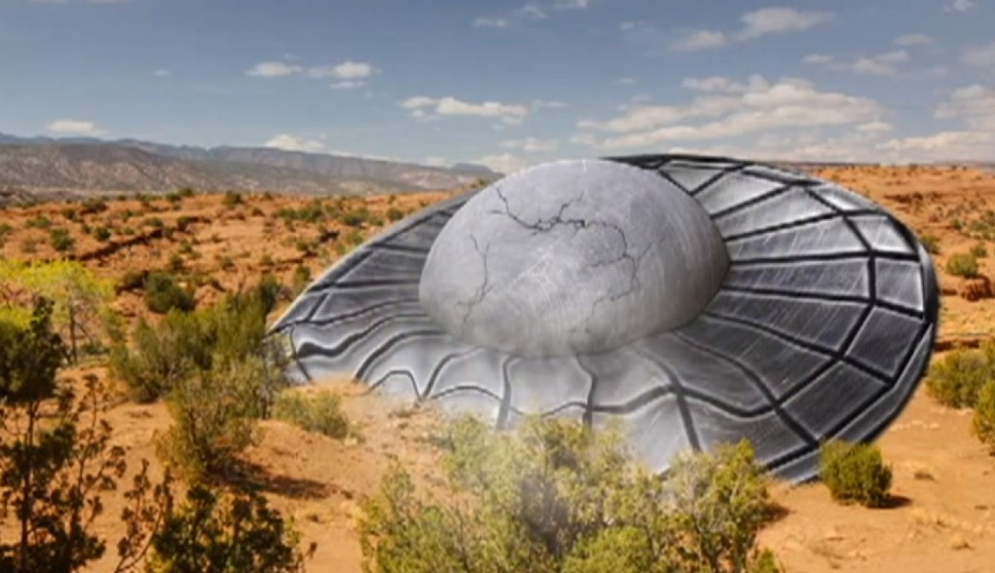
(The landing zone of the zygons’ spaceship)

After the rough landing, the two girls decide to investigate in the surrounding area, finding the UFO’s landing zone: the spaceship is still smoking and two zygons are lying slightly stunned nearby; other aliens, silurians, are unloading some boxes from the spaceship. Clara and Ashildr approach the ship while hiding but Clara steps on a branch, making noise and getting detected, the 12th Doctor comes out the spaceship, staring angrily at them and yells at the aliens to get rid of them; the aliens start to chase our adventurers. During the chase, Ashildr stumbles and falls to the ground. When they’re about to get reached from the creatures, two shots explode in the air, and the aliens fall on the ground dead. Jack Harkness gets out of the bushes, with his rifle still fuming, but he is not alone, as two more people come out: they are Sam Swift and Jenny, the Doctor’s daughter. After the greetings, Jack tells the girls that an anonymous informer told him about their arrival and that they were the only people who could save them. The reason of the presence of those Zygons in 1947 was still unknown. While examining the dead bodies of the creatures they immediately notice a small metal device, as big as a bottle cap, inserted in the aliens’ neck up to the point of the spinal cord. On the way back towards the spaceship, they come across a box, filled up with the very same tools, still there and ready to be used. The doctor had disappeared. The adventurers decide they need to find out what’s the purpose of the little tool all of this while wondering where the Doctor could have gone. Their next destination is a laboratory technologically advanced enough to understand and examine the device.

Once back to the Tardis they depart to reach their destination: it’s the very same place, on Earth, but 2000 years later. The group approaches a nearby city but there doesn’t seem to be anyone around. Streets are empty, cars are abandoned, nothing looks alive. While roaming around, they hear a voice calling them. A young Silurian had followed them intrigued by the Tardis, and he introduces himself as Alros: the Earth had been attacked 2 millenniums before and the whole population had been taken somewhere unknown. The roads are only patrolled by cybermen, looking for anomalies or any living being. silurians managed to survive since they live underground, hiding from the evil machines. His parents were killed by the cybermen and his little brother was kidnapped. The group shows the device to Alros, but he doesn’t recognise it; regardless he guides his new friends in a laboratory where it could be scanned and examined. After crossing the city with all the dangers involved, they find the lab and they find out that the device is actually a transmitter that sends signals to a planet in the Andromeda galaxy.

(An outside view of the factory)

(PROTOTYPED LEVEL)
They decide to find out who they’re dealing with. Following the radio signal they find a giant factory where a lot of people work as slaves. Our heroes try to investigate on who is responsible for all of this. Going through the rooms several clues are found that get the group closer and closer to the truth: the place is a huge foundry, where metal is worked to build sontaran’s armours. Strax, a sontaran who used to help the Doctor in the past, is the factory’s chief. The adventurers decide to face Strax and free the workers. While exploring the factory, the run across a group of scientists and when they free them the leader gives them his pass. They use that card in order to open the control office, and fight Strax.

After the battle Strax passes out, and the same device they’ve been analysing is found on his neck. After removing it the Sontaran wakes up, asking where he is and saying that he has no memory of the past few years: his last memory is a great pain to the neck. Strax calls for a few scientists among the slaves, which tell the group that the device is in fact a temporal energy controller, able to take control of its host remotely, the images of the 4 regenerations of the doctor are shown in loop in the mind of the subject, resulting in feelings of terror and fear. The source of Strax’s device is not just one, but four different ones, in location and times far from each other: Waflorix, Kobrorth, Steon A61 and Pledaclite. The team is divided between Ashildr and Jenny, who think the Doctor is acting and has a plan, and Clara and Jack, the ones who assert that the Doctor would never do such things, then Strax asks to join the team to redeem himself. Alros decides to look for his brother between the slaves, but while the search is taking place a siren rings announcing the self destruction of the planet in 20 minutes. Panic erupts among the crowd, as they head towards the closest spaceships. In this hell Alros is able to locate his sibling but unable to draw his attention. They eventually head to the Tardis and fly over the panicking people, trying to pinpoint the young one; they eventually find him and Alros grabs his arm while the timer is almost done. Other two desperate men hang on the little Silurian’s legs, preventing the group from lifting him onto the time machine. The little brother understands his fate is sealed, he lets go of his brother’s hand and the Tardis departs at 2 seconds left on the destruction timer, while Alros is screaming and the planet is starting to dissolve.

While the group manages to escape in the nick of time, Alros is destroyed and overwhelmed by the pain, so much that he passes out. Adjusting him in one of the available chairs they all agree that the real Doctor can’t be the cause of such pain, so they depart towards one of the 4 planets where the message branches off to destroy the 4 relays and stop the supposed Doctors. When Alros finally speaks up expressing his desire for revenge and his hatred for who was the cause of all this.

The player can visit the four planets in the order he prefers, choosing two characters to help Clara and Me between Alros, Jack, Jenny and Strax:
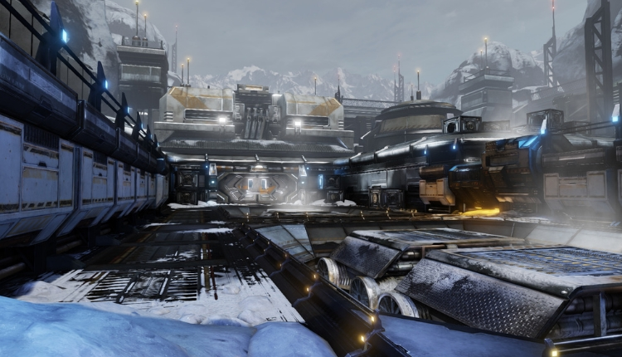
(Waflorix’s base entrance)
In Waflorix they find a mass of soldiers training. Here are led all the prisoners, forced by the Doctor and his cruel Sontaran jailer to train to become soldiers. The exploration of the barracks and its different rooms is conducted in the sneakiest way possible, as there are too many guards around. After different battles and clues, they come across War, the 9th Doctor, that once defeated loses control of its army: the player can choose to take the Sontarin jailer as a captive or to let him free (the choice will impact the finale), then they destroy the transmitter.

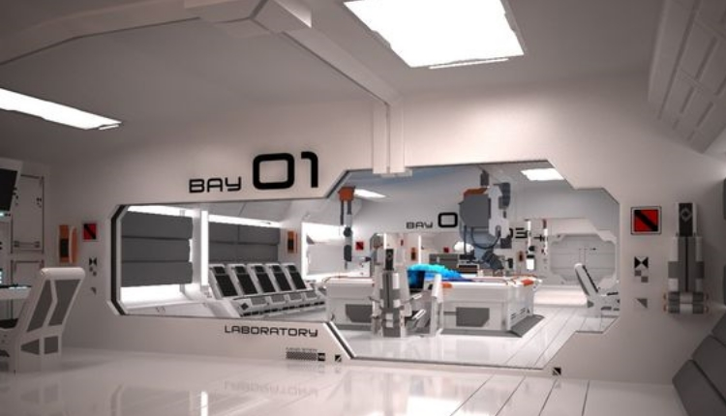
(A laboratory for cloning experiments in Steon A61)
Steon A61 looks like a giant lab, and this time the slaves are very few and mostly are scientific personnel, they are all humans guarded by armed Silurians. Here many species are used as lab rats for cloning experiments. After talking to a few researchers, beating some silurian guards and escaping from the weeping angels, attracted by a red sparkling substance they come across the captain of the lab. After their victory, the hood of the enemy is removed revealing The Rani, a scientist of the Time Lords banished from her people for the cruelty of her experiments. She is questioned, and the groups finds out that the Doctors are gathering an alliance of all the species afraid of him: the player can choose to take her has a captive or to let her free (the choice will impact the finale). Whatever the player chooses, suddenly, the Rani gets hit by a huge shock, which pulverises her while she screams her lungs out, it’s the 10th Doctor who calls himself Famine, that killed her because of no use any more. They defeat him too. Before leaving the planet they destroy the relay.

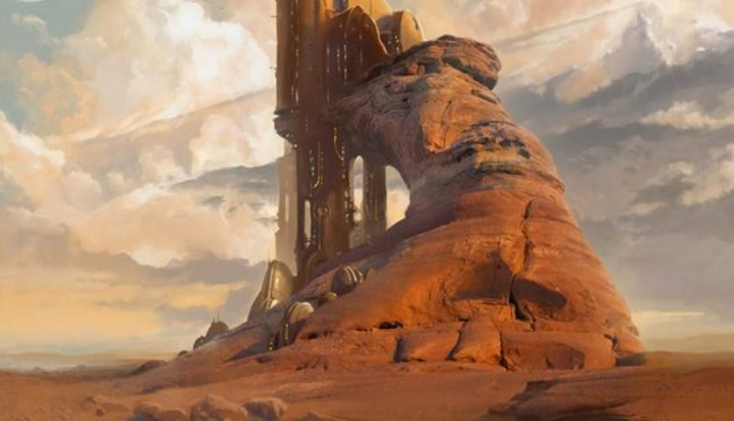
(Main drill for excavations in the mine)
In Kobroth the whole population is held captive by a group of ice warriors, working in what looks like a mine. What are they looking for? All the slaves are held in chains, with a collar that seems to shock people who decide to take a breather. In a remote room they find out what the slaves are looking for, Zeiton-7, a red sparkling mineral with great temporal properties which fuels the Tardis but attracts many weeping angels too. After a few battles they get to the head of the outpost, the 11th Doctor he calls himself Conquest, accompanied by an Ice Warrior general. The doctor greets our heroes and then he immediately attacks; when they manage to take him out, he speaks up saying “It’s too late, she has already all planned”. The ice warrior general begs mercy: the player can choose to take him as captive or to let him free (the choice will impact the finale). Before departing Ashildr takes a vial of Zeiton-7, as she finds it extremely interesting, they then destroy the transmitter and release all the slaves.

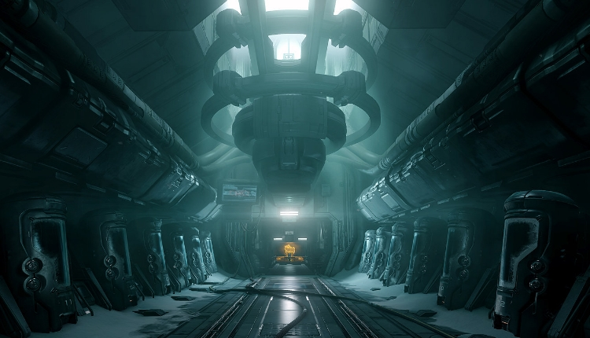
(Storage area of the capsules containing different aliens races)
On Pledatite they find a multitude of closed capsules. When they get off from the Tardis and get close to one, the heroes find out that those contain inside different being of different races coming from all corners of the universe, and many weeping angels are roaming nearby. With these horrible news and frightened by the creepy sight they head towards the source of the signal. At the base of the transmitting tower they find Death, the 12th Doctor. When he sees the adventurers he immediately fights them. While they deactivate the tower they try to find out why those capsules are out there; in a hidden room they find a surgeon working on a corpse. They discover that the bodies are drained from their temporal energy which is then stored for a following use but have attracted the weeping angels in the meanwhile: the player can choose to take him as captive or to let him free (the choice will impact the finale), they then destroy the relay.

Once the four planets are freed, the group puts together the clues they had found: the 4 Doctors were actually evil clones made using the Zeiton-7 and the temporal energy stored and they were used to force many species to gather up in an enormous army, but who made this? And what was the purpose of the army? While they are still discussing a video of Missy reaches the group, unveiling her plan: she managed to capture the Doctor, and now she plans to use her army. When the video is over they manage to locate its source through a complex process.
Once on the planet, they fall in an ambush where they’re taken prisoners. Missy finally tells them that they will attend to the end of the universe and her revenge on the Time Lords.
The team is held captive in different cells, but Clara manages to brilliantly escape her cell and sneakily reaches all her companions cells and free them one by one. When they are all together again they head to the Master’s room.

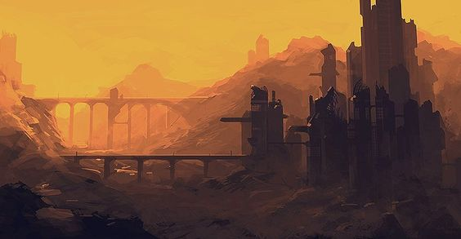
(Missy’s hideout)
When they’ get to the room where his plan is going to take place, they find the Doctor trapped in a cage, unable to talk. Missy assert that the Doctor is not so different from herself. Their both known with fear, their names are associated to dread. They both assembled a deadly army to help them, Missy has her Alliance, the Doctor has his companions. She then presents the last part of the army: the Daleks enter into the room through a portal. Last time the Doctor and her met, she was left in Daleks’ hands, and she bargained her life for Gallifrey and all the time lords. Her army united with the Daleks will be able to take on the Time Lords and allow Missy to take her final revenge, but she has to make her final step: cloning herself. The team has heard everything and hurry to stop her, but the Daleks use all their resources to slow them. At the end they manage to reach the cloning room, but Missy is already connected to the cloning machine and using three little drops of the Zeiton-7 she makes three clones of herself that help her to fight the heroes. After a long fight, Clara manages to sneakily reach the machine and pour the Zeiton-7 vial previously taken into it. The machine overloads and explodes, destroying the clones and the dalek’s portal, Missy is left slightly stunned while the team begins to celebrate.

GOOD FINALE (there are more freed guardians): Missy is defeated and spared by the team, the Doctor is liberated and he congratulates with them for showing mercy. After greeting the team members, but not recognizing Clara, he departs forcing Missy to follow him, to free the species forced in the Army and to redeem his name, so it can be associate again to “hope” once again, while teaching Missy what mercy consists in.

BAD FINALE (there are more imprisoned guardians): Missy is defeated, Alros tries to kill her for revenge, but the Doctor screams, distracting him and allowing Missy to escape. The Doctor is liberated but he’s furious, showing no mercy is not the right way to act, taking captives and killing can’t do any good. His name might be corrupted for ever. He then departs to go in a solitude meditation, to find out if Missy was actually right about them being similar.

